EYNSHAM DAY CENTRE

CORONAVIRUS UPDATE

We have made the difficult decision to suspend our services at the Day Centre with immediate effect until further notice. We have done this with regret but feel it is the right, and responsible, thing to do. Our members all fall into the ‘higher risk’ category and Oxfordshire is one of the most affected counties in the UK.

We will endeavour to keep our volunteers and members closely informed but in the absence of immediate further information, please presume that we will be closed for the foreseeable future.

One thing is certain however - we will reopen as soon as it is safe to do so; we will take our lead from the Government and the health/science experts advising them.

We are very happy to discuss this further with anyone involved; please use the contact numbers provided on our website. If any members anticipate any personal difficulties as a result of our closure then please contact us and we will see how we can support you.

In the meantime, please follow government guidelines and protect yourselves as best you can.

Critically:

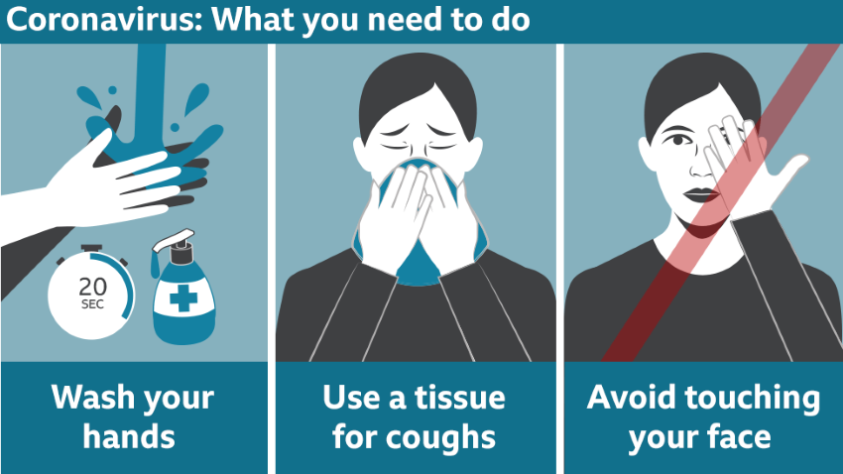

Stay well and see you soon!

Mark Johnson
Deputy Chairman & Treasurer

eynshamdaycentre.com

